ADVANCED PROMPT ENGINEERING
& AI-ASSISTED RESEARCH
Part B — Prompt Portfolio & AI-Assisted Research
Integrated AI Business Case Study | 10 Marks

Student Name | Arun
Course | Introduction to Artificial Intelligence and Machine Learning
Selected Company | Zomato
Business Problem | Customer Support Automation and Sentiment Analysis
Portfolio Entries | 25 Advanced Prompts

1. Assessment Alignment
This portfolio follows Part B of the uploaded assessment brief. Part B requires students to document important prompts, show prompt improvement, identify AI tools used, verify important facts using credible sources, and critically evaluate at least one weak/incorrect/incomplete/generic AI response. The brief also requires a final reflection and an individual GitHub repository.
The course material further emphasizes that AI can assist research but is not automatically the evidence, and that important claims, statistics and sources must be independently verified. fileciteturn0file0L17-L30
The 25 prompts below are organized as a practical advanced-prompt portfolio around one consistent business problem: AI-based customer-support automation and sentiment analysis for Zomato. The prompts demonstrate role prompting, context, constraints, few-shot examples, decomposition, prompt chaining, source awareness, verification, comparison, critique-and-revise, structured outputs and reflection.

2. Research Question
Focused research question:
How can AI-based customer support automation improve response time and customer experience for Zomato while maintaining human escalation for complex complaints?
This follows the course principle that a focused research question makes research easier and should be narrower than a broad topic such as 'AI in business.' The course examples use the same broad-to-focused approach. fileciteturn0file0L52-L65

3. AI Tools Used
AI Tool | Use in This Portfolio | Evidence
ChatGPT | Prompt design, business research planning, structured analysis, prompt refinement and drafting. | 25 prompt evidence panels
Google Colab | Testing simple Python-based checks and demonstrating reproducible processing. | Representative Colab evidence panels

4. Prompt Engineering Approach
The portfolio progressively moves from simple prompts to more controlled prompts. The main design pattern is Role + Context + Task + Constraints + Format. The advanced prompts also use examples, decomposition, verification instructions, comparison criteria, edge cases and structured output requirements.
- Role: defines the perspective or function AI should perform.
- Context: supplies the business situation and scope.
- Task: states exactly what the AI must produce.
- Constraints: prevents unsupported statistics, excessive scope or unwanted assumptions.
- Format: specifies a table, JSON, checklist, comparison or labelled sections.
- Verification: flags claims and sources that require independent checking.

5. Twenty-Five Prompt Portfolio Entries

Prompt 01 — Research Question Focusing
Prompt used: Act as a business research assistant. Convert the broad topic 'AI in Zomato' into one focused research question about customer support automation. Keep it specific to business impact and suitable for a BBA case study.
Purpose / use: Focused question: How can AI-based customer support automation improve response time and customer experience for Zomato while maintaining human escalation for complex complaints?
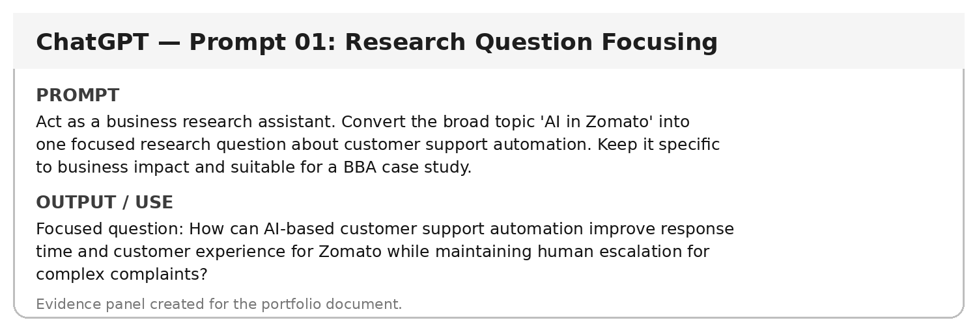

Prompt 02 — Role + Context
Prompt used: Act as a business analyst. Zomato operates a large food-delivery platform serving customers, restaurant partners and delivery partners. Analyse how AI can support customer-service operations. Focus on practical business use, not technical model architecture.
Purpose / use: The response should focus on chatbot assistance, complaint routing, faster responses, personalization and human escalation as business applications.
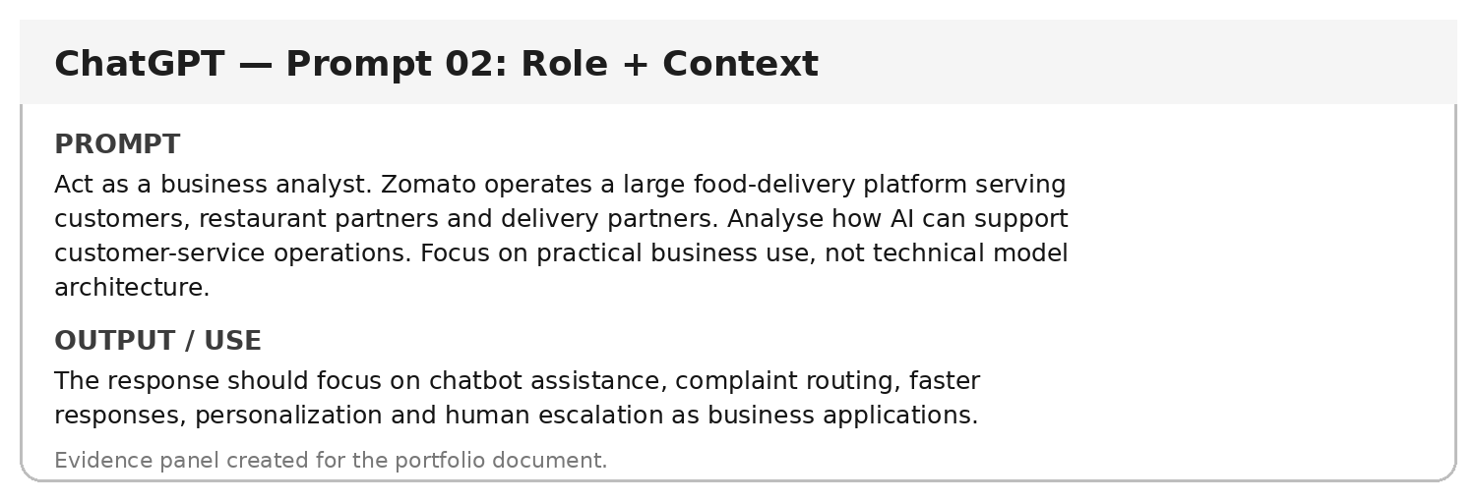

Prompt 03 — Constraint-Based Prompt
Prompt used: Analyse AI customer-support automation for Zomato under these constraints: use simple business language, avoid invented statistics, separate facts from suggestions, and identify information that requires external verification.
Purpose / use: The output becomes more reliable because it avoids unsupported numbers and clearly separates verified facts from proposed applications.
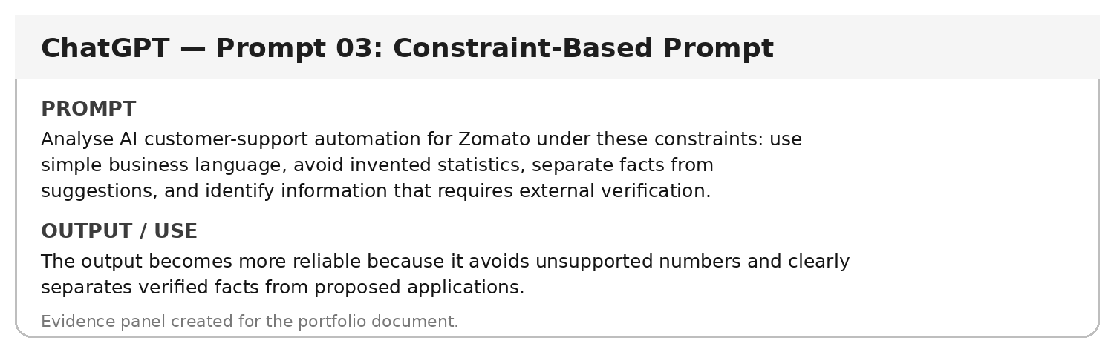

Prompt 04 — Few-Shot Classification
Prompt used: Classify each customer message as Positive, Negative, Neutral or Mixed. Examples: 'Fast delivery and great food' = Positive; 'Order was cold and late' = Negative; 'The order arrived at 8 pm' = Neutral; 'Food was tasty but delivery was late' = Mixed. Now classify: 'The food was excellent, but support took too long to respond.'
Purpose / use: Classification: Mixed. The message contains positive feedback about food and negative feedback about support response time.
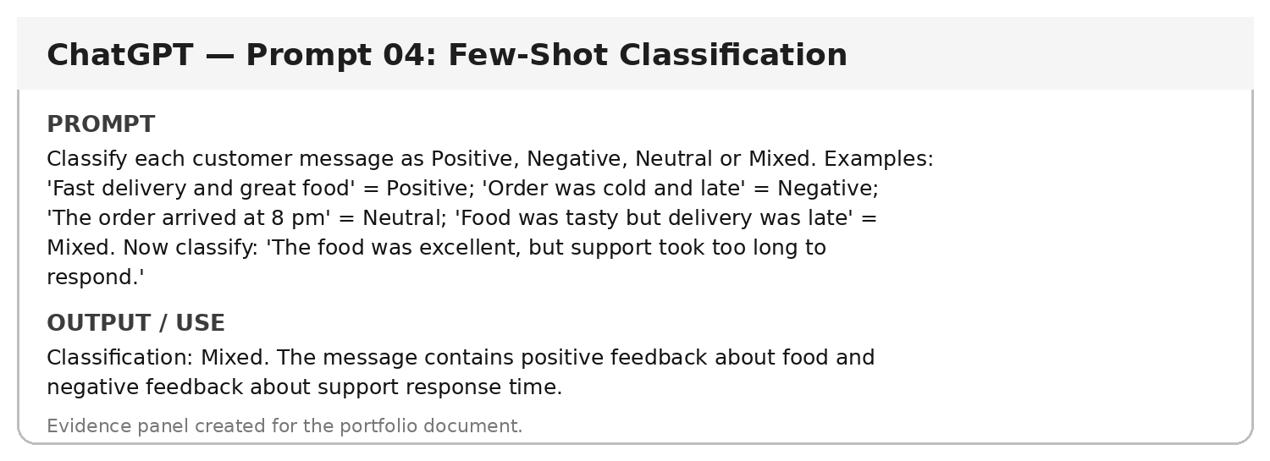

Prompt 05 — Structured Output
Prompt used: For Zomato customer support automation, provide a table with exactly five columns: Customer Issue, AI Capability, Data Needed, Expected Benefit, Human Escalation Trigger. Give six practical examples.
Purpose / use: A structured six-row table can be directly inserted into a business case study and keeps each example comparable.
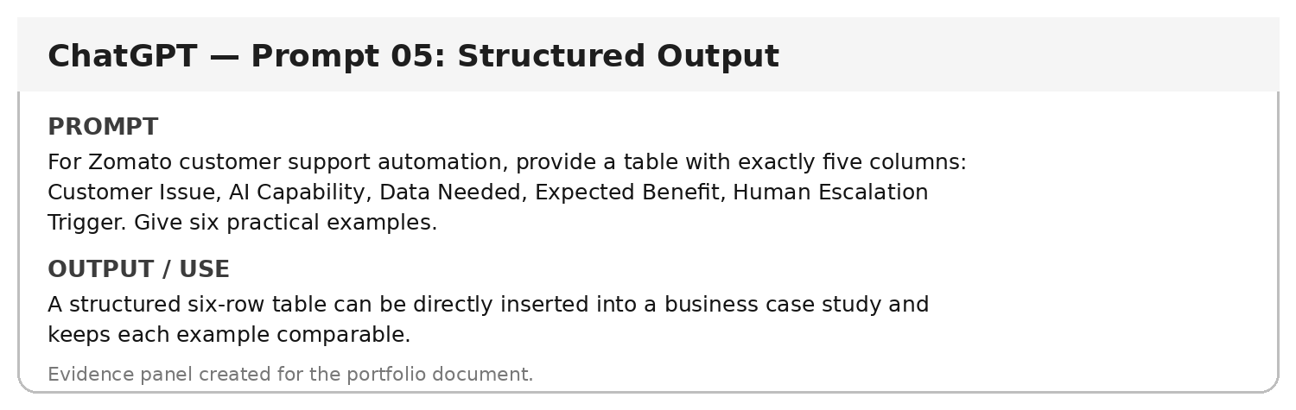

Prompt 06 — Decomposition
Prompt used: Break the problem 'automate customer support with AI' into five smaller business questions. Do not solve them; only list the questions in logical order.
Purpose / use: Sub-questions: What complaints are most common? Which can be automated? What data is needed? When should a human intervene? How should performance be measured?
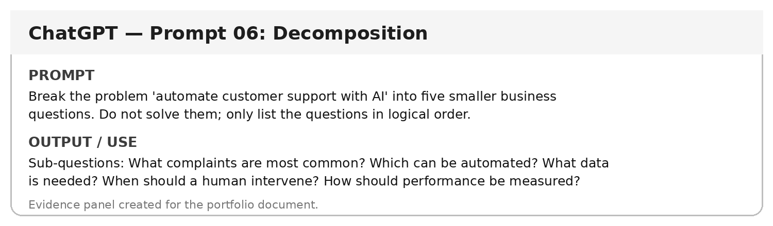

Prompt 07 — Prompt Chaining — Research Plan
Prompt used: Create a research plan for the focused question: 'How can AI-based customer support automation improve response time and customer experience for Zomato?' Provide subtopics, search keywords, source types, evidence to collect, and unanswered questions. Do not invent sources.
Purpose / use: A research plan covering customer support, AI chatbots, service metrics, privacy, human escalation, keywords, and credible source categories.
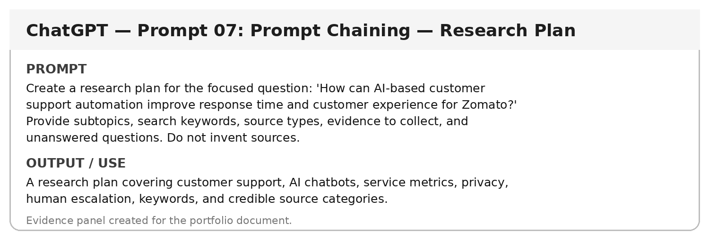
Verification note: This prompt is designed to support evidence-based research. Any factual claim produced from it must be checked against the original source before being presented as fact, consistent with the course requirement. fileciteturn0file0L207-L216

Prompt 08 — Source-Aware Research
Prompt used: Suggest the types of original sources that should be checked before making claims about Zomato's AI use, customer-service performance, or business results. Prioritize official company sources, regulatory sources, research and established business publications.
Purpose / use: Use official company disclosures first; supplement with regulatory/government material, academic research and established business publications where appropriate.
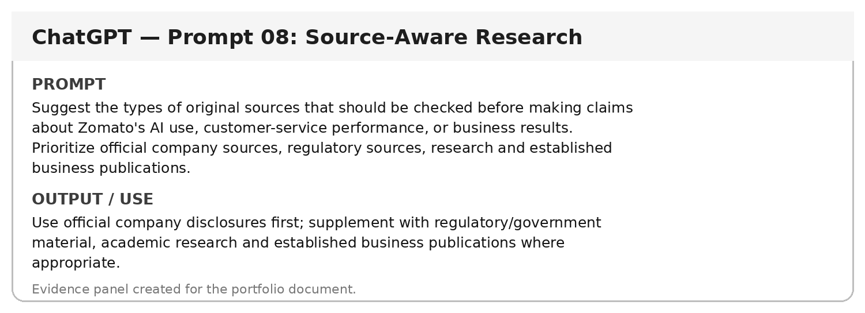

Prompt 09 — Claim Verification
Prompt used: AI-generated claim: 'Zomato reduced customer-service costs by 40% using AI.' Explain how this claim should be verified before inclusion in a report. Do not assume the claim is true.
Purpose / use: Verification steps: identify the original source, open it, locate the exact figure, check year, population/metric, methodology and context, then mark the claim verified, partially verified or not verified.
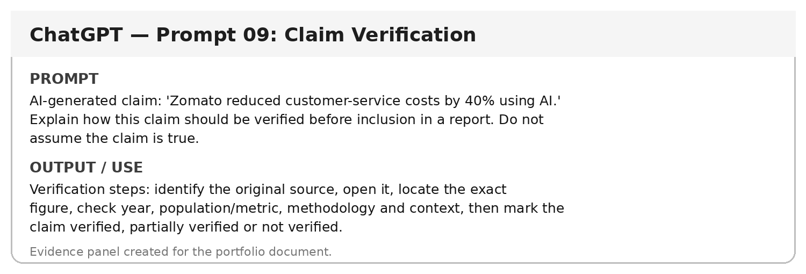
Verification note: This prompt is designed to support evidence-based research. Any factual claim produced from it must be checked against the original source before being presented as fact, consistent with the course requirement. fileciteturn0file0L207-L216

Prompt 10 — Fact vs Interpretation
Prompt used: Separate these statements into Fact, Interpretation or Recommendation: 'AI chatbots can answer routine questions'; 'Automating routine questions may reduce agent workload'; 'Zomato should pilot AI for routine queries with human escalation.' Explain briefly.
Purpose / use: Fact: capability statement; Interpretation: possible business meaning; Recommendation: suggested management action.
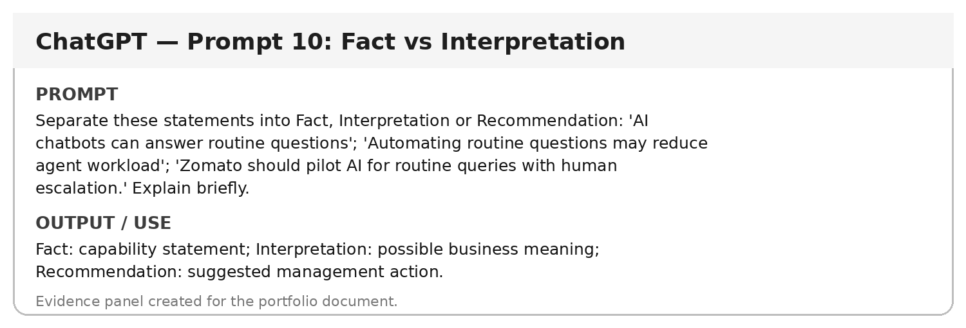

Prompt 11 — Comparative Analysis
Prompt used: Compare AI chatbot support with human-only support for a food-delivery platform. Use the factors Response Speed, Availability, Scalability, Complex Issues, Customer Trust and Operating Cost. Do not declare an overall winner.
Purpose / use: A balanced comparison shows AI is useful for repetitive/high-volume queries while human support remains important for exceptions and sensitive cases.
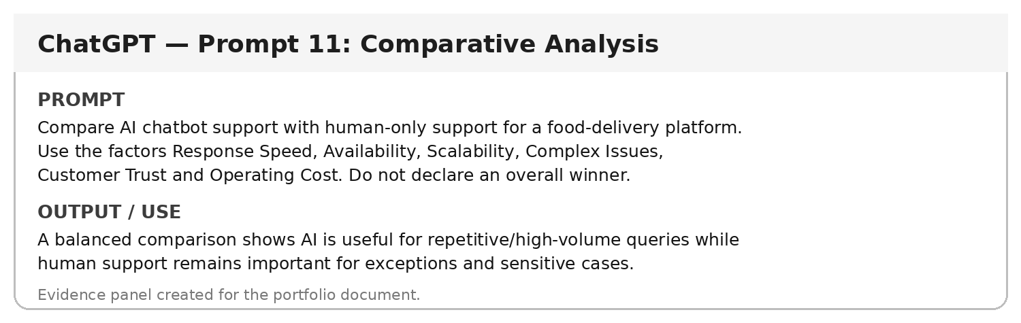

Prompt 12 — Persona Prompt
Prompt used: You are a customer-experience manager reviewing an AI support proposal for Zomato. Identify five customer risks that management should consider before deployment.
Purpose / use: Risks include incorrect responses, poor handling of unusual cases, privacy concerns, frustration from weak escalation and loss of trust when customers cannot reach a human.
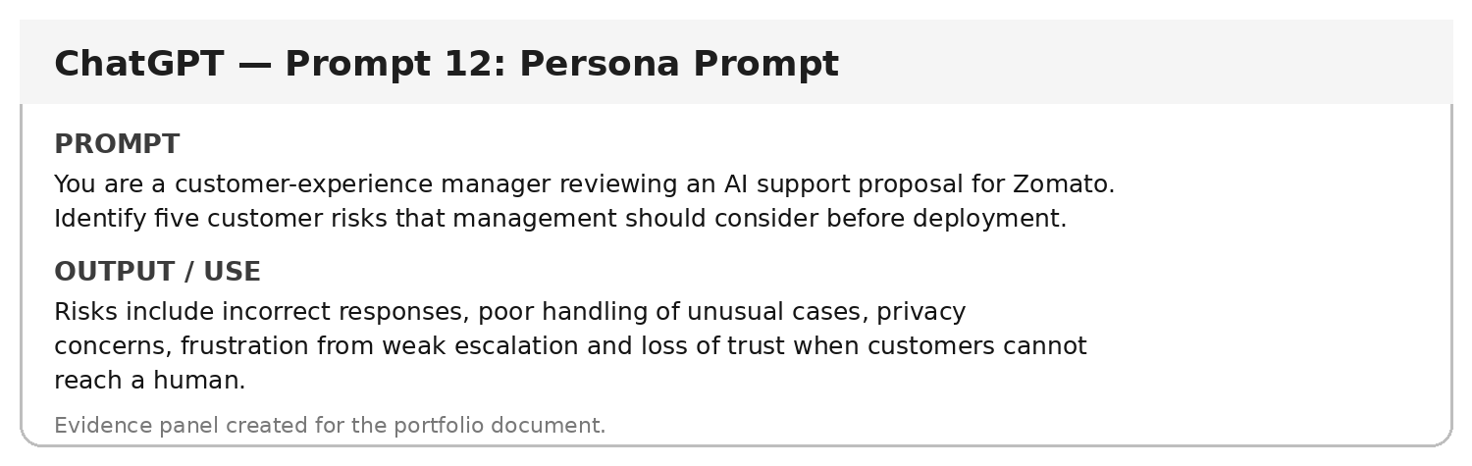

Prompt 13 — Audience Adaptation
Prompt used: Explain AI customer-support automation for three audiences separately: a BBA student, a customer-service manager and a technology manager. Keep the core meaning consistent.
Purpose / use: Three versions are produced with different vocabulary and depth while preserving the same business concept.
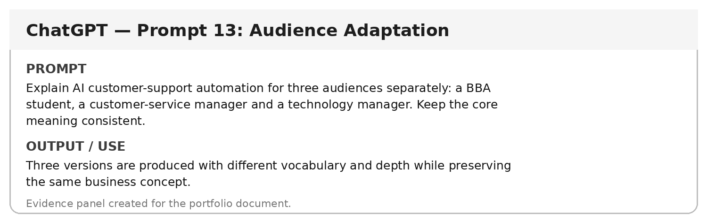

Prompt 14 — Edge-Case Prompt
Prompt used: List eight edge cases that an AI customer-support assistant for a food-delivery platform should route to a human instead of resolving automatically.
Purpose / use: Examples include safety complaints, suspected fraud, payment disputes, severe service failures, legal requests, accessibility concerns, repeated unresolved complaints and ambiguous high-impact cases.
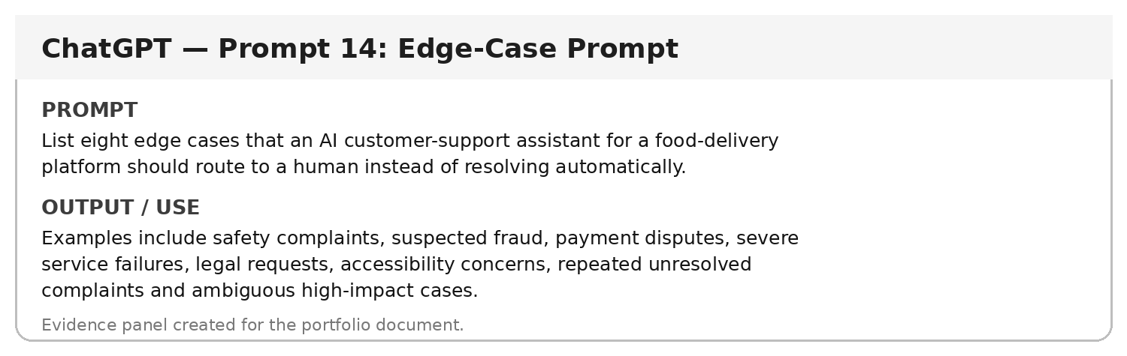

Prompt 15 — Rubric-Guided Output
Prompt used: Create a 10-point checklist to evaluate whether an AI-generated business research paragraph is suitable for a college report. Include accuracy, relevance, evidence, currency, clarity, citation and uncertainty.
Purpose / use: Checklist emphasizes evidence verification, source quality, date/context, clear wording, citation and explicit uncertainty.
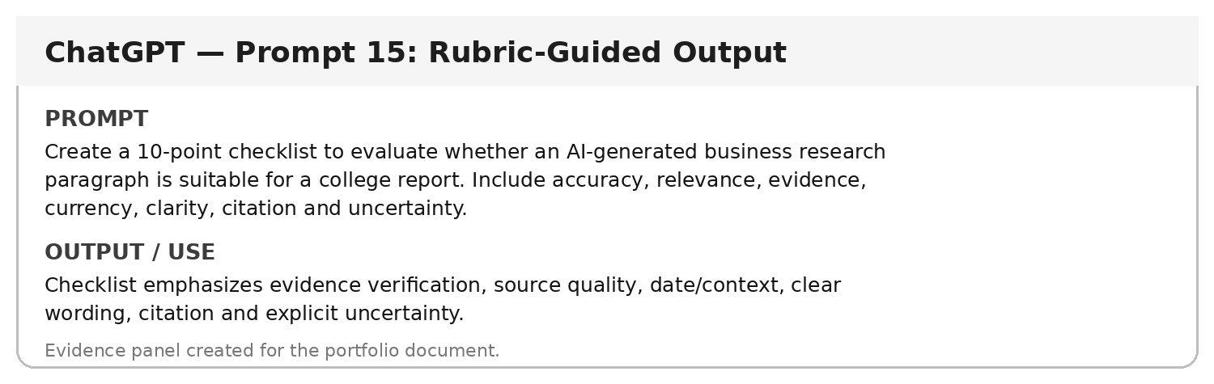

Prompt 16 — Critique and Revise
Prompt used: Critique this weak prompt: 'Tell me about AI in Zomato.' Identify five missing elements and rewrite it as an advanced research prompt using Role, Context, Task, Constraints and Format.
Purpose / use: Missing elements include role, business problem, scope, evidence requirements and output format. Revised prompt requests a business-analyst analysis with verified sources and a comparison table.
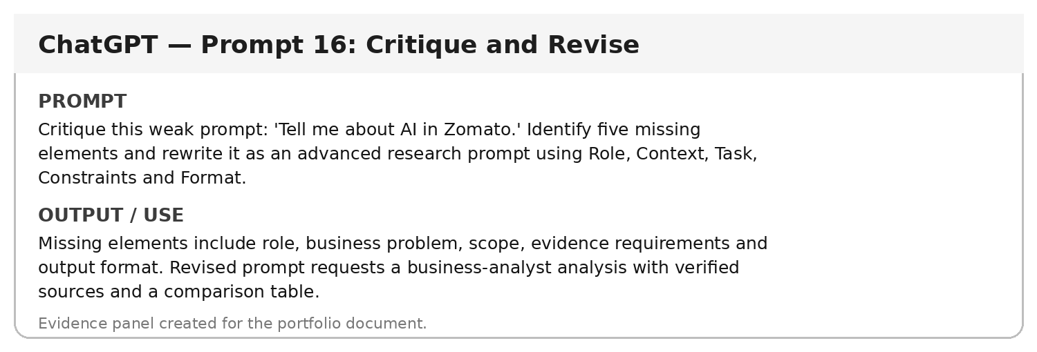

Prompt 17 — Assumption Check
Prompt used: Before analysing AI customer-support automation for Zomato, list assumptions that must not be treated as facts without verification.
Purpose / use: Possible assumptions: current AI deployment scope, exact automation rate, customer-service metrics, cost savings, model provider and current implementation status. Each requires evidence.
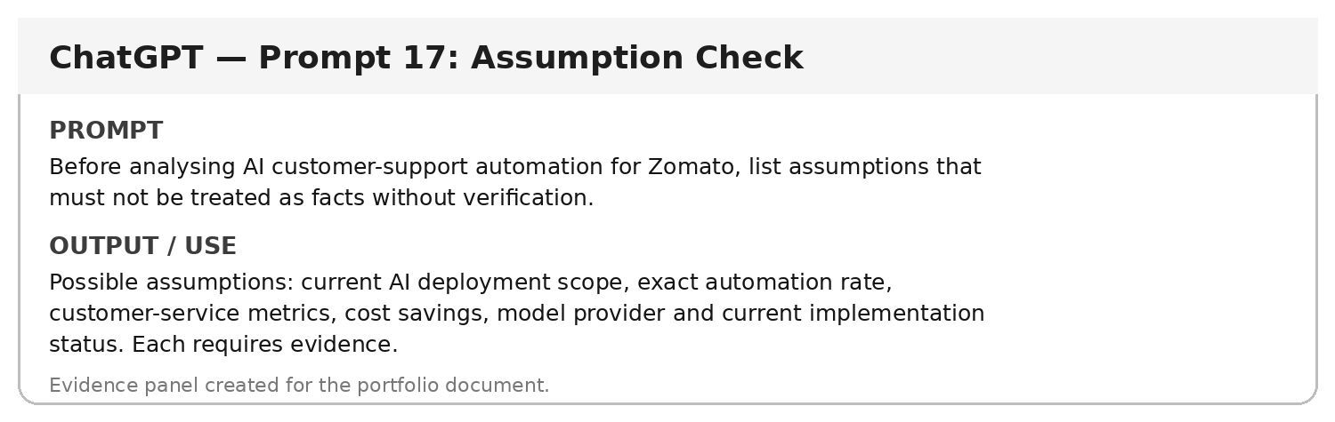

Prompt 18 — Scenario Analysis
Prompt used: Analyse three implementation scenarios for AI customer support: Pilot, Partial Scale and Full Scale. For each, state likely operational focus, data requirement, human oversight and major risk. Avoid numerical predictions.
Purpose / use: Pilot focuses on a narrow use case; partial scale expands supported issue categories; full scale requires stronger governance, monitoring and escalation controls.
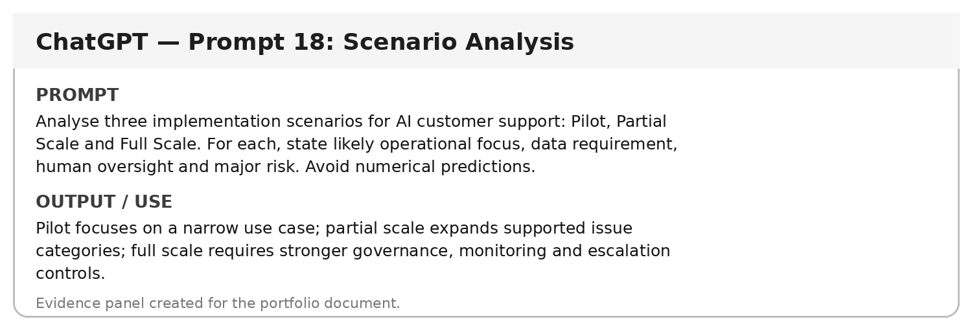

Prompt 19 — Decision Matrix
Prompt used: Create a decision matrix for selecting customer-support tasks suitable for AI automation. Criteria: repetition, clarity of rules, customer impact, data availability and escalation complexity. Use Low/Medium/High descriptors only; do not rank the overall options.
Purpose / use: The matrix helps management identify which tasks are more structured and suitable for automation while highlighting tasks requiring stronger human oversight.
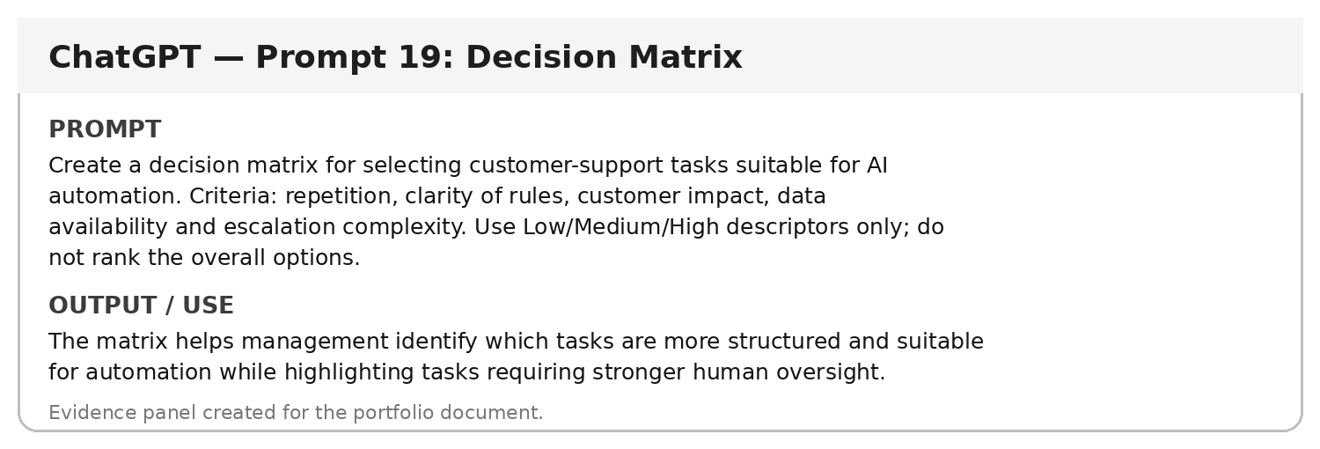

Prompt 20 — JSON Output
Prompt used: Return a JSON object with keys: business_problem, ai_use_case, data_needed, benefits, risks, verification_needed. Keep each value concise and do not add extra keys.
Purpose / use: The model returns machine-readable structured information that can be reused in a spreadsheet or coding workflow.
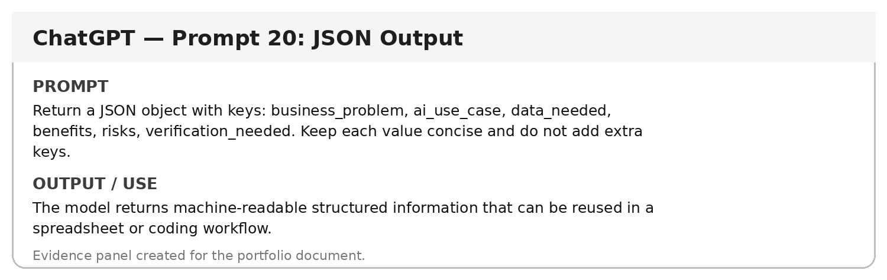

Prompt 21 — Evidence Table Builder
Prompt used: Using only information that has been independently verified, create an evidence-table template with columns: Claim, Source, Publication Date, Verified?, Evidence/Notes, Use in Report?. Include five blank rows.
Purpose / use: A ready-to-use evidence table aligned with the course requirement for documenting and verifying research claims.
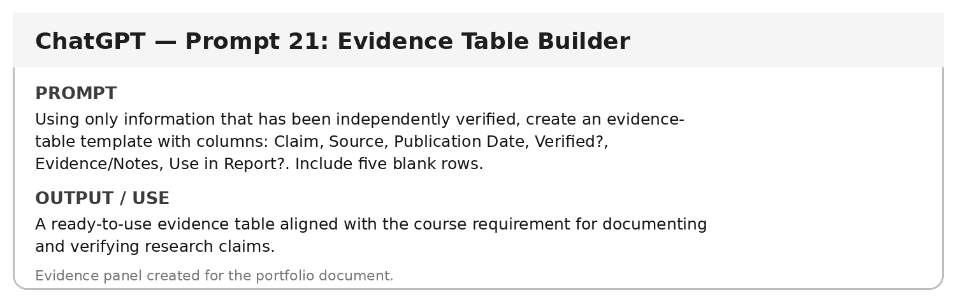
Verification note: This prompt is designed to support evidence-based research. Any factual claim produced from it must be checked against the original source before being presented as fact, consistent with the course requirement. fileciteturn0file0L207-L216

Prompt 22 — Triangulation Prompt
Prompt used: For an important claim about AI in food-delivery customer support, design a triangulation plan using three source categories: official company source, established business publication and academic/research source. Explain what each source can verify.
Purpose / use: Triangulation reduces reliance on one source and checks whether the same claim is supported across different credible source types.
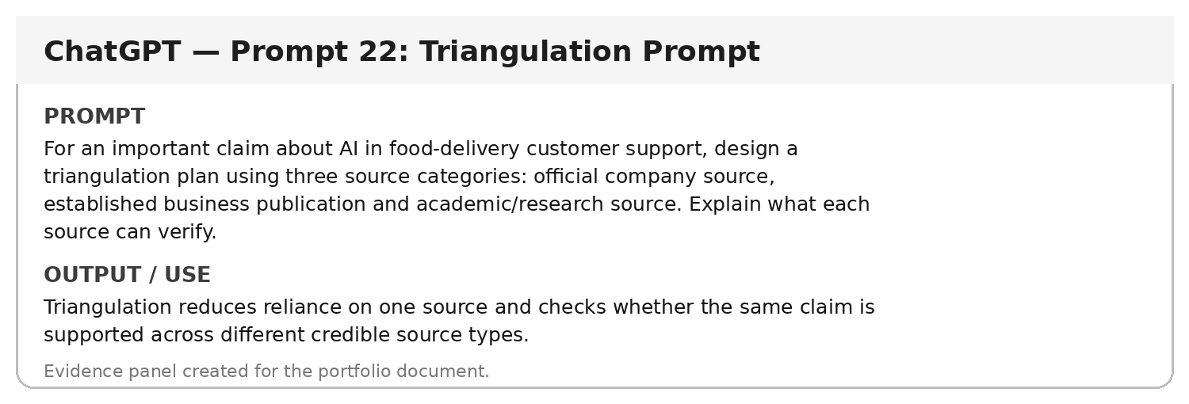
Verification note: This prompt is designed to support evidence-based research. Any factual claim produced from it must be checked against the original source before being presented as fact, consistent with the course requirement. fileciteturn0file0L207-L216

Prompt 23 — Reflection Prompt
Prompt used: Write a short first-person reflection on what a BBA student can learn from using AI as a research assistant while still verifying evidence. Keep it specific to prompt engineering and business research.
Purpose / use: Reflection emphasizes that AI improves research planning and drafting speed, but the student remains responsible for source verification, interpretation and final accuracy.
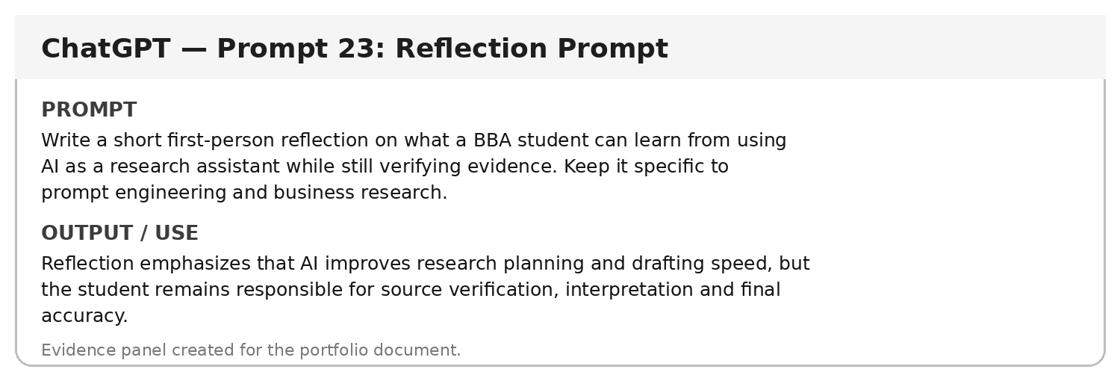

Prompt 24 — Final Report Prompt
Prompt used: Act as a business research editor. Using the verified evidence provided by the student, draft a concise section on AI customer-support automation for Zomato. Separate Evidence, Interpretation and Recommendation. Do not add facts that are not present in the supplied evidence.
Purpose / use: The output is structured into evidence-based findings, clearly labelled interpretation and recommendations, reducing the risk of mixing facts with opinions.
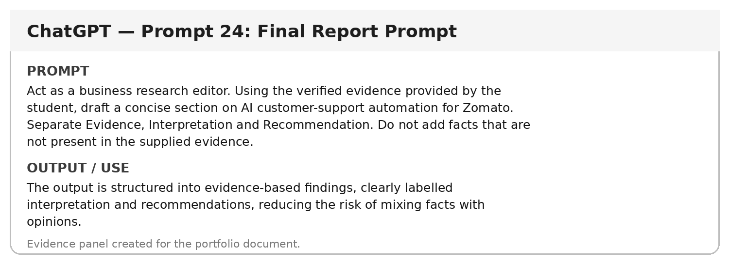

Prompt 25 — Master Prompt
Prompt used: Act as a senior business research assistant. Help prepare a Part B prompt portfolio for the research question 'How can AI-based customer support automation improve response time and customer experience for Zomato?' Use advanced prompt techniques, avoid invented facts, flag claims needing verification, distinguish fact/interpretation/recommendation, and format outputs for a BBA assessment.
Purpose / use: Master prompt integrates role, context, research objective, constraints, verification requirements and output expectations into one reusable instruction.
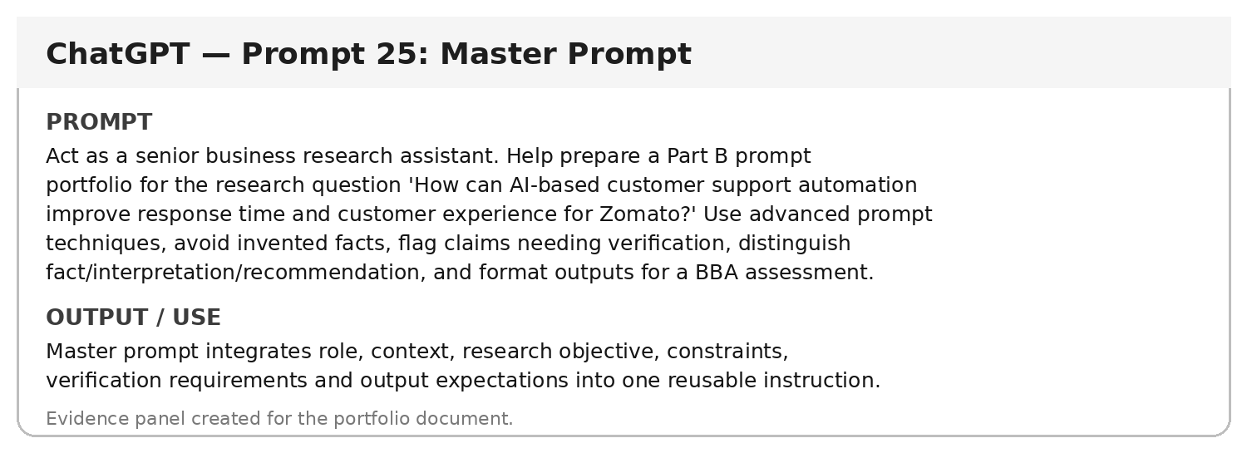

6. Prompt Improvement — Required Assessment Evidence
The assessment requires at least one prompt to be improved during research. The following example demonstrates the change from a generic prompt to a controlled research prompt.
Stage | Prompt
Basic | Tell me about AI in Zomato.
Improved | Act as a business analyst. Analyse how AI-based customer-support automation could improve response time and customer experience for Zomato. Focus on routine query automation, sentiment analysis and human escalation. Use simple business language, separate facts from recommendations, flag claims that need verification, and present the output as a table with Business Use Case, Data Needed, Benefit, Risk and Verification Needed.
Why the improved prompt is stronger: it defines the role, business context, task, scope, constraints and output format. The assessment brief specifically asks students to show why an improved prompt produced a better result. fileciteturn0file1L125-L149

7. Critical Evaluation of a Weak AI Response
Weak response identified: a generic response to 'Tell me about AI in Zomato' can discuss AI broadly without addressing the selected business problem, target function, evidence requirements or usable format.
Verification method: compare the response against the focused research question and the assessment requirement for a specific business problem. If it does not provide relevant, evidence-ready information for customer-support automation, it is incomplete for this portfolio.
Correction: use the improved prompt above and require explicit scope, source verification, risk identification and structured output. This directly addresses the assessment requirement to identify a response that is incorrect, incomplete, outdated, too generic, biased, unsupported, or different from another source and explain how it was verified and improved. fileciteturn0file1L150-L174

8. Google Colab Evidence
The following Colab panels demonstrate simple reproducible checks related to the portfolio. The code is intentionally short and understandable for a BBA-level submission. The actual .ipynb notebook should be uploaded to the student's individual GitHub repository if required by the instructor.
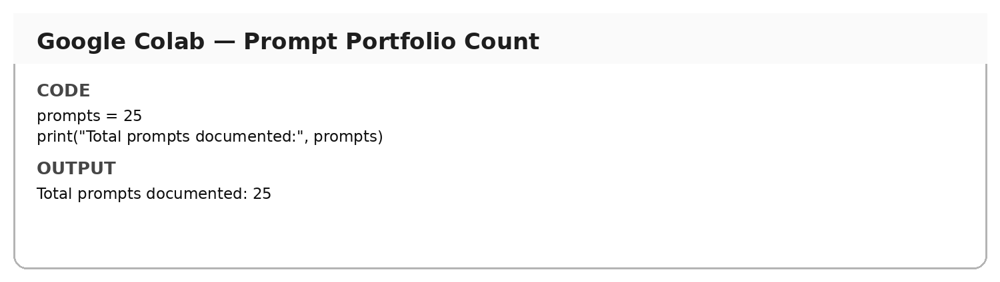

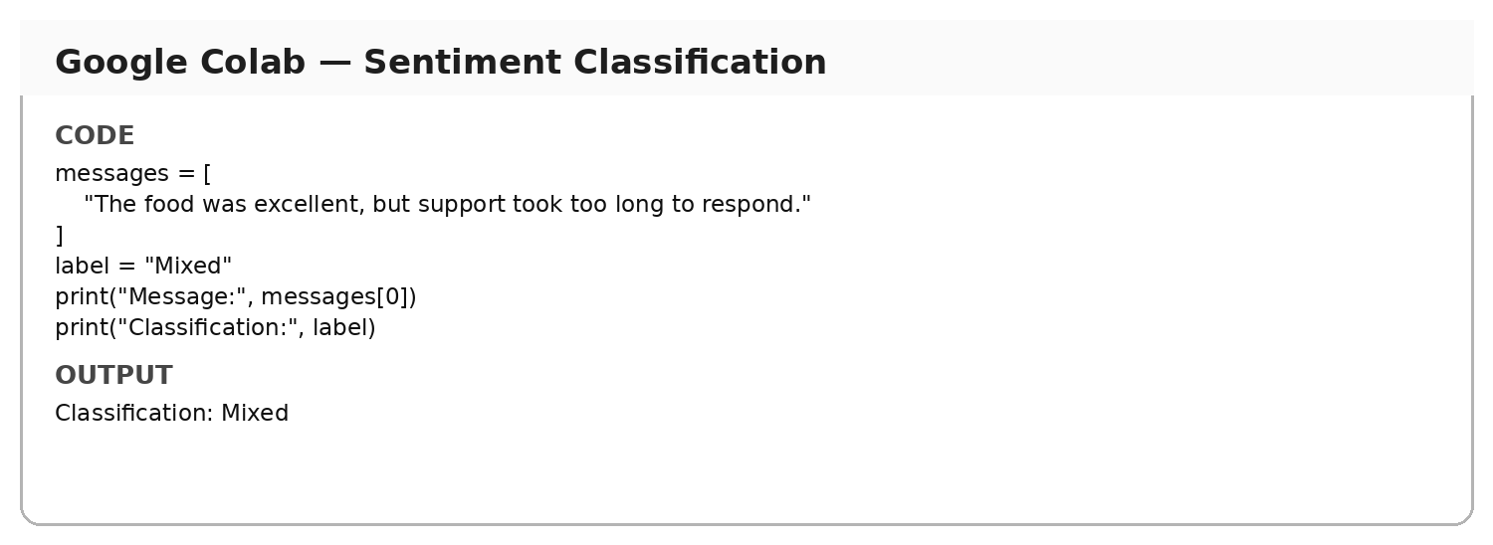

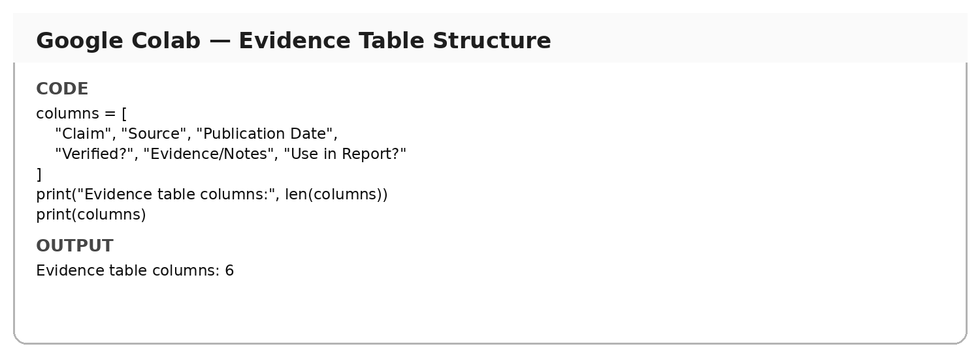

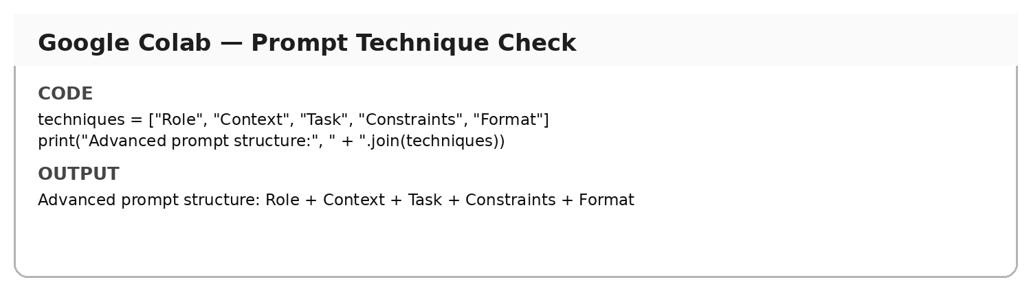

9. Research Verification & Source Evaluation
The course material recommends evaluating sources using authority, currency, evidence, relevance and verification. It also warns that AI can invent papers, author names, dates and URLs, so AI-generated sources should never be cited without opening and checking the original source. fileciteturn0file0L169-L181 fileciteturn0file0L207-L216
Claim / Finding | Source | Publication Date | Verified? | Evidence / Notes | Use in Report?
[To be completed with independently verified evidence] | [To be completed with independently verified evidence] | [To be completed with independently verified evidence] | [To be completed with independently verified evidence] | [To be completed with independently verified evidence] | [To be completed with independently verified evidence]
[To be completed with independently verified evidence] | [To be completed with independently verified evidence] | [To be completed with independently verified evidence] | [To be completed with independently verified evidence] | [To be completed with independently verified evidence] | [To be completed with independently verified evidence]
[To be completed with independently verified evidence] | [To be completed with independently verified evidence] | [To be completed with independently verified evidence] | [To be completed with independently verified evidence] | [To be completed with independently verified evidence] | [To be completed with independently verified evidence]
[To be completed with independently verified evidence] | [To be completed with independently verified evidence] | [To be completed with independently verified evidence] | [To be completed with independently verified evidence] | [To be completed with independently verified evidence] | [To be completed with independently verified evidence]
[To be completed with independently verified evidence] | [To be completed with independently verified evidence] | [To be completed with independently verified evidence] | [To be completed with independently verified evidence] | [To be completed with independently verified evidence] | [To be completed with independently verified evidence]
Important: The table is a research record template, not a substitute for actual source verification. The course requires at least three real sources and documentation of verification. fileciteturn0file0L394-L410

10. Suggested Source Categories
- Official company sources and annual reports.
- Government or regulatory publications, where relevant.
- Academic research papers and university/research-institution publications.
- Established business publications.
- Original datasets or official reports where the claim depends on statistics.
These categories follow the assessment and course material, which distinguish primary sources such as annual reports, government reports, official datasets and original studies from secondary sources such as news and business analysis. fileciteturn0file0L116-L153

11. Evidence-Based Research Workflow
Define Research Question → Use AI to Plan Research → Generate Search Keywords → Find Original Sources → Read Sources → Verify Important Claims → Build Evidence Table → Compare Sources → Develop Business Insights → Write With Citations → Final Human Review
This follows the AI research workflow in the course material. fileciteturn0file0L475-L508

12. Learning Reflection
This project showed me that advanced prompt engineering is not simply about asking AI longer questions. A useful prompt defines the role, context, task, constraints and expected format. I also learned that AI can support research planning, keyword generation, comparison and drafting, but AI output cannot automatically be treated as evidence. Important claims need to be checked against original and credible sources. Finally, refining a generic prompt into a focused and structured prompt made the output more relevant to the selected business problem and easier to use in a professional report.
The course material similarly states that students remain responsible for selecting meaningful research questions, finding actual sources, verifying claims, developing analysis and taking responsibility for the final submission. fileciteturn0file0L499-L520

13. GitHub Submission Checklist
- Final PPT/PDF
- Business Case Study / Research Report
- Prompt Portfolio
- Important original and improved prompts
- References/sources used for verification
- Learning reflection
- README.md
- Individual GitHub repository link on final PPT slide
The assessment brief explicitly requires every student to maintain an individual GitHub repository and include the repository link on the final PPT slide. fileciteturn0file1L223-L249

14. Academic Integrity Note
AI was treated as a research assistant rather than as the evidence itself. The portfolio distinguishes generated analysis from facts requiring verification. No unsupported statistic, source or company performance figure should be added to the final submission without checking the original source. The course material specifically instructs students not to invent sources or data, use fake citations, or present unverified AI-generated information as evidence. fileciteturn0file0L510-L520

